Sprint 1 Plan

Decentralized Application Framework (DAPPF)

Kirill, Anthony, Garrett, Shishir, Vincent

10/6/21

Completion Date: 10/19/21

Revision Number: 2

Revision Date: 10/6/2021

**Goal:**

The goal of this sprint is to build the groundwork for our framework.

**User Stories:**

User story 1 (“As a developer, I would like to connect two nodes”)

* Task 1: C(2 hours)

Total for user story 1: 20 hours

**Team Roles:**

Vincent: Team lead, Scrum Master, Developer

Kirill: Developer

Anthony: Developer

Garrett: Developer

Shishir: Developer

**Initial Task Assignment:**

Vincent:

* User Story: “As a developer, I would like to connect two nodes”
* Task 1

Kirill:

* User Story: “As a developer, I would like to connect two nodes”
* Task 1

Anthony:

* User Story: “As a developer, I would like to connect two nodes”
* Task 1

Garrett:

* User Story: “As a developer, I would like to connect two nodes”
* Task 1

Shishir:

* User Story: “As a developer, I would like to connect two nodes”
* Task 1

**Initial Burnup Chart:**

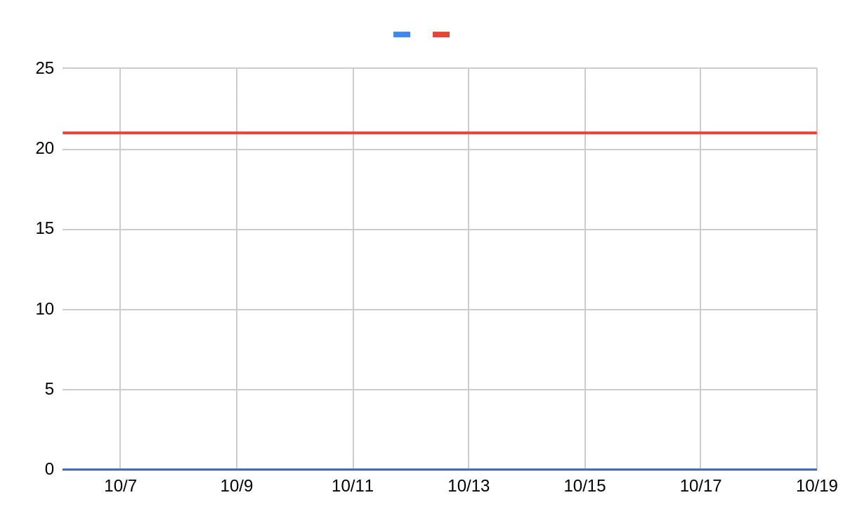

**Initial Scrum Board:**

| **User Stories** | **Tasks Not Started** | **Tasks In Progress** | **Tasks Completed** |
| --- | --- | --- | --- |
| “As a developer, I would like to connect two nodes” |  | Task 1 |  |

**Scrum Times:**

Meetings:

* Tuesday at 5pm
* Wednesday at 5pm
* Saturday at 12pm

Scrum meeting:

* Tuesday at 1 pm